Presentation of release calendar of statistical data and dissemination calendar of press data
Through this service, it is possible to obtain information about the release calendar of statistical data and the dissemination calendar of press data. To use the electronic service, it is necessary to enter the "E-services" section on the official website of the State Statistical Committee (http://www.stat.gov.az/) and enter the e-service "Submission of the release calendar of statistical data and the dissemination calendar of press data" from the list of electronic services. (Picture:1)

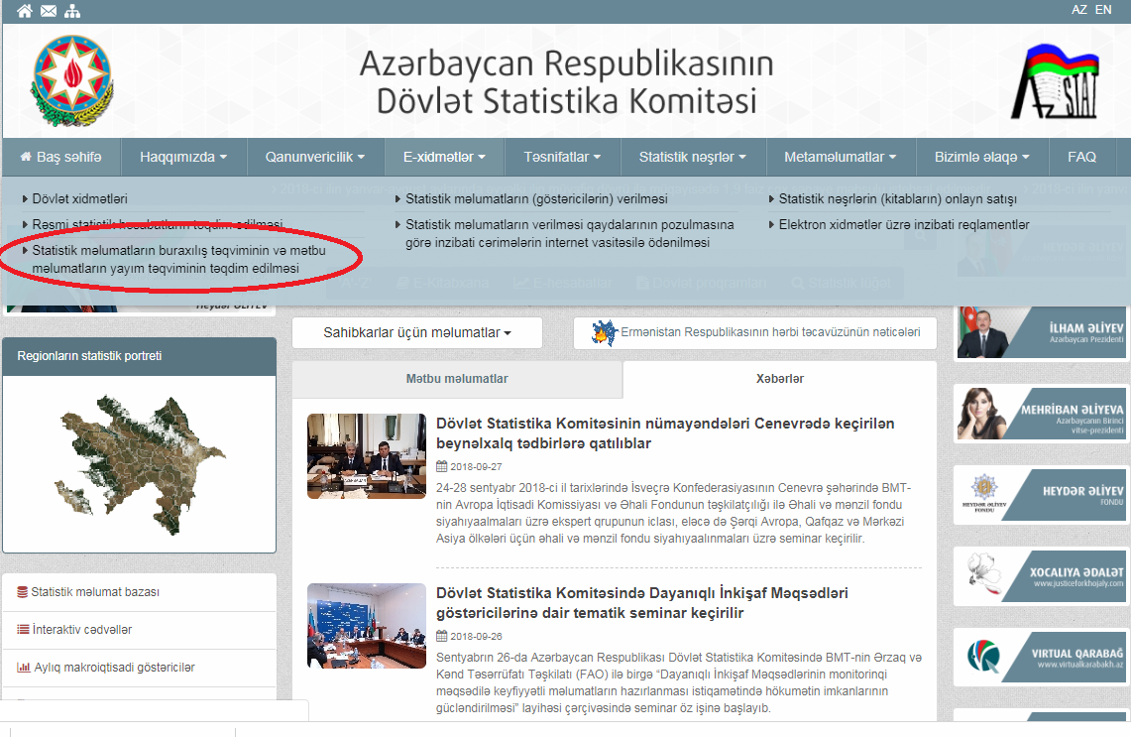
Picture:1
The window that opens when entering the service provides the user with dissemination calendar of press data for different years. (Pic:2)

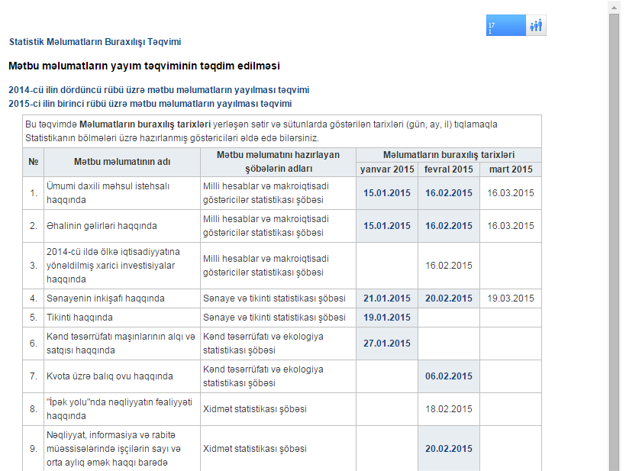
Picture:2
It is possible to obtain indicators developed on statistical sections by selecting the dates indicated in the rows and columns in the release dates of user data in the calendar. (Pic:3)
